**Mathematics (Chapter – 1,15)**

( Attempt All Questions. )

1. Simplify :
${3^{(\frac{1}{5})}}^{4}$

2. ${13}^{\frac{1}{5}}$. ${17}^{\frac{1}{5}}$
${(\frac{1}{3^{3}})}^{7}$

$\frac{{11}^{\frac{1}{2}}}{{11}^{\frac{1}{4}}}$

3. Rationalise the denminator of the following:
$\frac{1}{\sqrt{7}-\sqrt{6}}$

$\frac{1}{\sqrt{5}+\sqrt{2}}$

$\frac{1}{\sqrt{7}-2}$

$\frac{1}{7+3\sqrt{2}}$

4. Represent $\sqrt{9.3}$ on the number line.
5. Simplify each of the following expressions:
$\left(3 + \sqrt{3}\right)(3 - \sqrt{3})$

$\left(3 + \sqrt{3}\right)(2+ \sqrt{2})$

${\left(\sqrt{5} + \sqrt{2}\right)}^{2}$

$\left(\sqrt{5}- \sqrt{2}\right)(\sqrt{5}+ \sqrt{2})$

6. Multiply $2\sqrt{2}$ by $2\sqrt{5}$
7. Divide $8\sqrt{15}$ by $2\sqrt{3}$
8. Check whether $7\sqrt{5}$, $\frac{7}{\sqrt{5}}$, $\sqrt{2}$, $21$, $π-2$ are irrational numbers or not.
9. Express the following in the form $\frac{p}{q}$, where p and q are integers and q ≠ 0.
$0.\overline{6}$

$0.4\overline{7}$

$0.\overline{001}$

10. Find an irrational number between $\frac{1}{7}$ and $\frac{2}{7}$
11. Express 3.142678 in the form $\frac{p}{q}$, where p and q are integers and q ≠ 0.
12. Find the decimal expansions of $\frac{10}{3}$, $\frac{7}{8}$ and $\frac{1}{7}$
13. Show how $\sqrt{5}$ can be represented on the number line
14. Eleven bags of wheat flour, each marked 5 kg, actually contained the following weights of flour (in kg): 4.97, 5.05, 5.08, 5.03, 5.00, 5.06, 5.08, 4.98, 5.04, 5.07, 5.00. Find the probability that any of these bags chosen at random contains more than 5 kg of flour.
15. In a cricket match, a batswoman hits a boundary 6 times out of 30 balls she plays. Find the probability that she did not hit a boundary
16. An organisation selected 2400 families at random and surveyed them to determine a relationship between income level and the number of vehicles in a family. Theinformation gathered is listed in the table below:

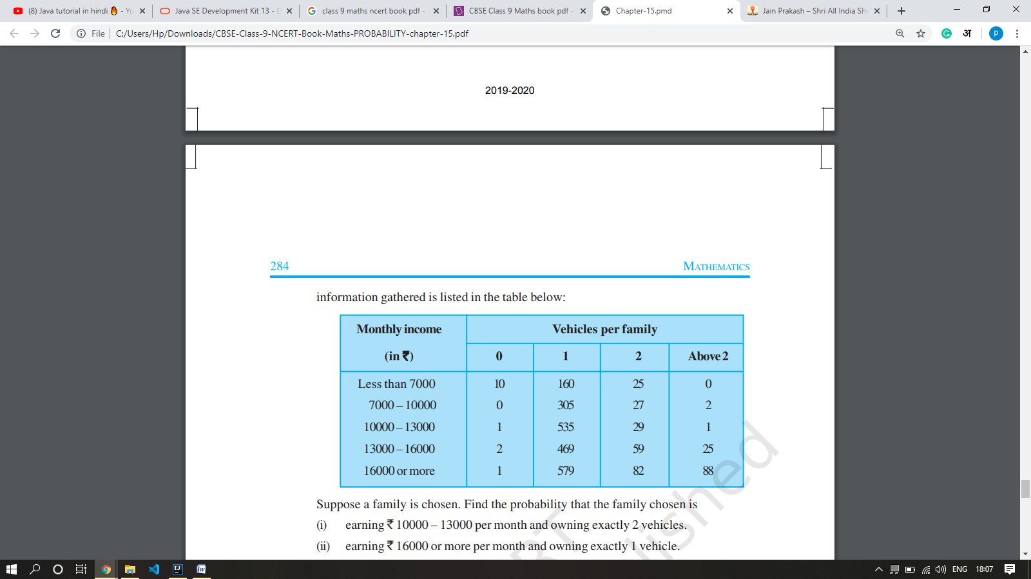

Suppose a family is chosen. Find the probability that the family chosen is

1. earning Rs. 10000 – 13000 per month and owning exactly 2 vehicles
2. earning Rs. 16000 or more per month and owning exactly 1 vehicle.
3. earning less than Rs. 7000 per month and does not own any vehicle
4. earning Rs. 13000 – 16000 per month and owning more than 2 vehicles.
5. owning not more than 1 vehicle